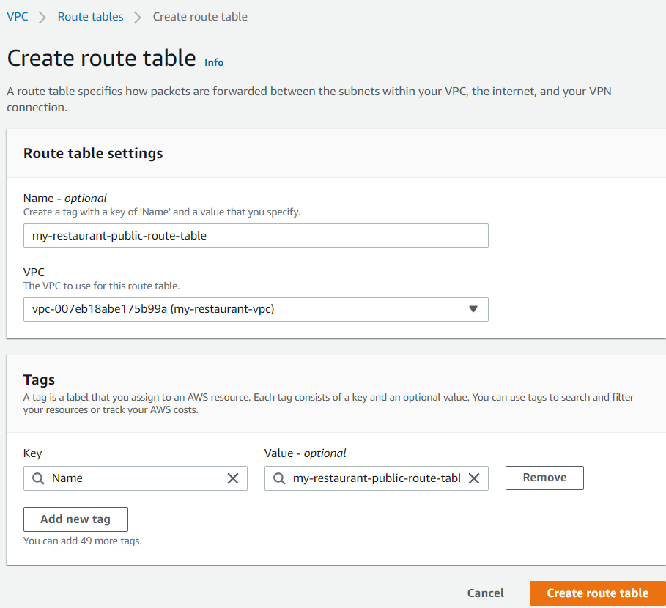

Add a route with Target as the IGW created in previous step:

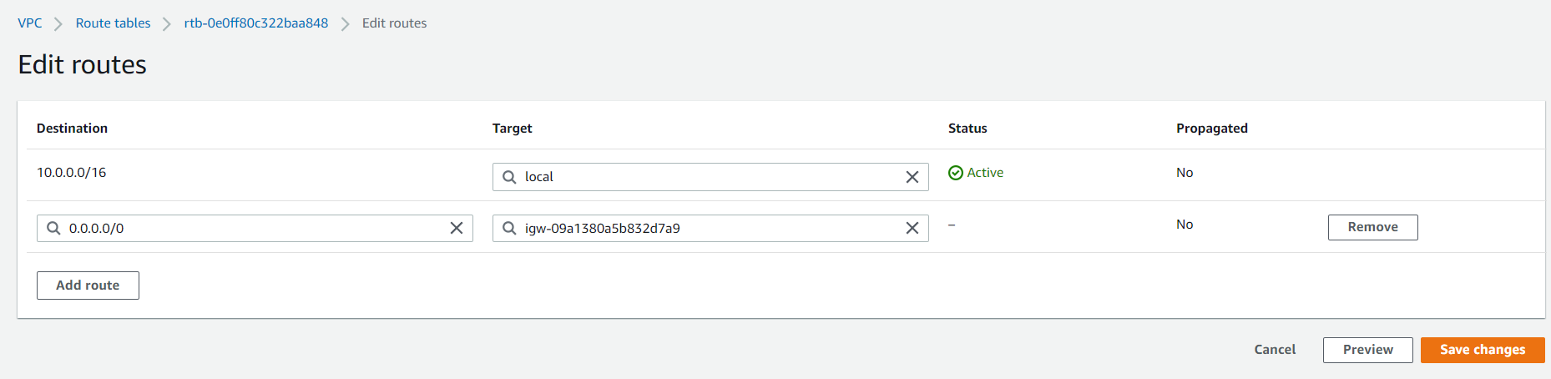

Click on the route table -> Actions -> Edit subnet associations and attach the route table to the 2 my restaurant public subnets.

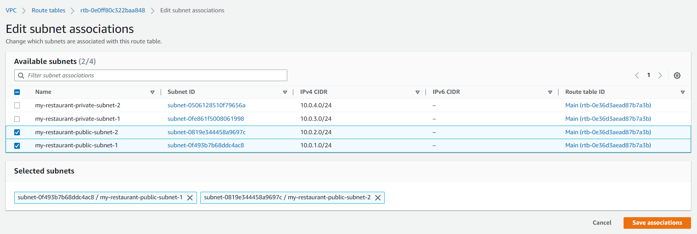

It is only now that the public subnets have become truly public.